http://screencast.com/t/JbK4brvL4YpC
Yogendra, this is a video from Craig showing you what we’re looking for on all of the editors.

SynapseIndia-: As per the system integrated in the website, same can not be managed in this way. We need to manage the emails at scripts level as it is running currently.

We need to be able to edit these emails in admin so it must be clear on the back end (admin) where they all go to on the front end. In our admin…Can you title each email I’ve listed below under mail type so we are clear on where they go?

- Welcome Trainer/Club from PtP (generated when trainer or club owner signs up for 30 day free trial or registration)
- Free Nutritional Guide
- Welcome Client from Trainer (generated by trainer when he invites or adds a client)
- Client Purchases (generated by trainer when he sells sessions to a client)
- Client Session Reminder – 24 Hour Reminder
- Client Session Status – (notification for completed, cancel no charge, cancel charged & complimentary sessions)
- Welcome Trainer from Club Owner (generated by club owner when he invites or adds a trainer)
- Welcome Client from Club Owner (generated by club owner when he invites or adds a client)
- New Client Notfication for Trainer (generated when club owner assigns trainer a new client)

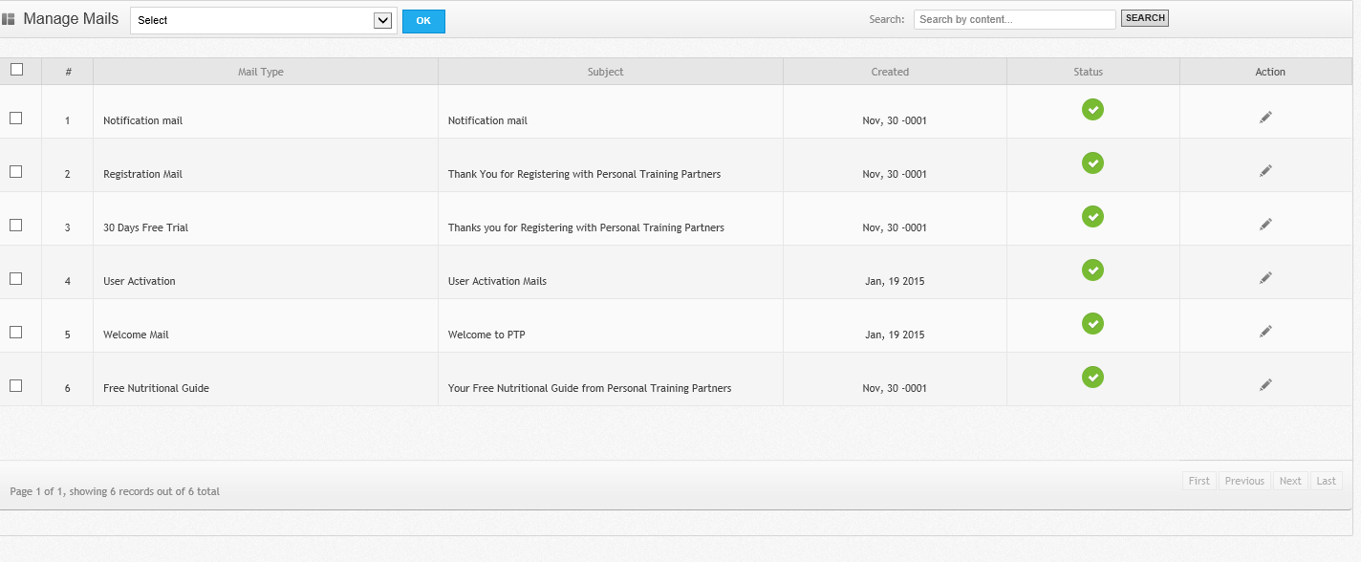

1: Mail Type: Welcome/30 day free trial
Mail Subject: Thank You for Registering with Personal Training Partners

OK

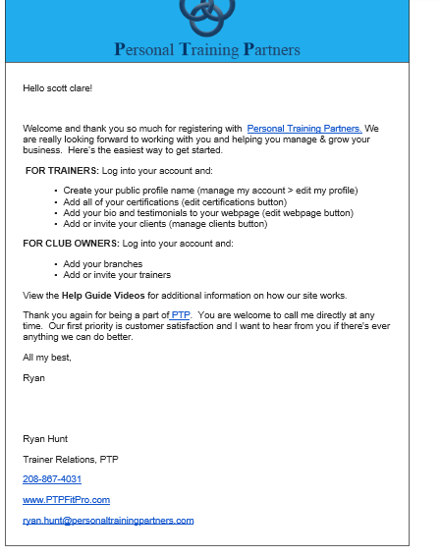
2: Mail Type: Welcome/Registration
Mail Subject: Thank You for Registering with Personal Training Partners

OK

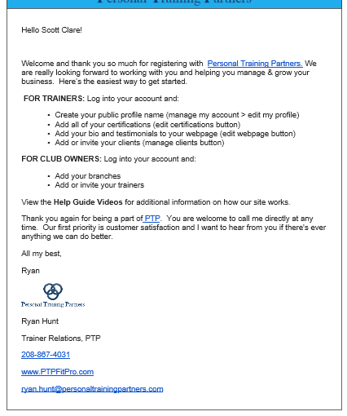

3: Mail Type: Free Nutritional Guide
Mail Subject: Your Free Nutritional Guide from Personal Training Partners

Ok

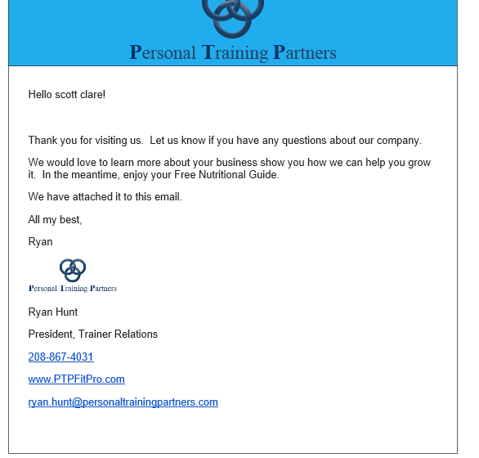

4: Mail Type: Welcome Client/Invite from Trainer
Mail Subject: Welcome
Trainer’s Logo
Hello (client)!
I’m inviting you to use my training software to help us reach your fitness goals.
Please find the link and your log in credentials below. Once you’re logged in click on “edit profile” to change your password. Then just fill in the empty fields.
Website URL: (trainer’s webpage URL)
Username: (clients email
Password: (auto generated password)

I’m excited to work with you! In the meantime, let me know if you need anything.

Thanks,

(trainer name)
(trainer’s phone number)
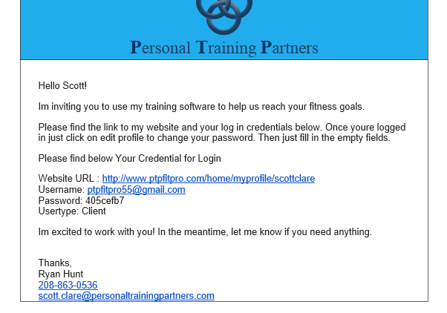
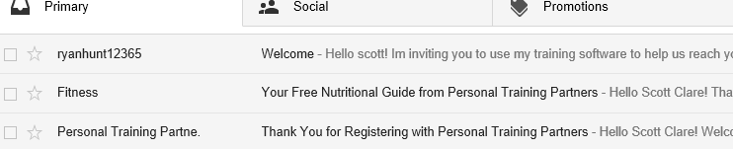
9:16 AM (5 minutes ago)
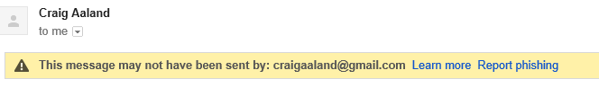
Let’s have all correspondence through our system from trainer to client say “Personal Training” instead of trying to use the trainer’s name. I don’t think Google likes us using the trainers name and having it come from our site...

5: Mail Type: Welcome Client/Add Trainer
Mail Subject: Welcome
Trainer’s Logo
Hello (client)!
I’m inviting you to use my training software to help us reach your fitness goals.
Please find the link to my website and your log in credentials below. Once you’re logged in just click on “edit profile” to change your password. Then just fill in the empty fields.
Website URL: (trainer’s webpage URL) .
Username: (clients email)
Password: (auto generated password)
I’m excited to work with you! In the meantime, let me know if you need anything.
Thanks,
(trainer name)
(trainer’s phone number)
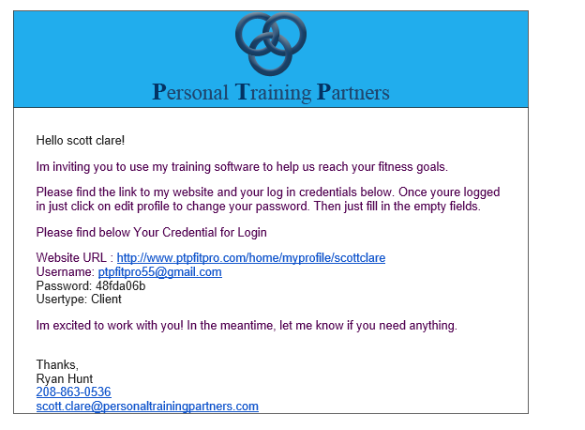
9:16 AM (5 minutes ago)
Let’s have all correspondence through our system from trainer to client say “Personal Training” instead of trying to use the trainer’s name. I don’t think Google likes us using the trainers name and having it come from our site...

6: Mail Type: Client Purchases
Mail Subject: Thank you for Purchasing Training Sessions

Trainer’s Logo
Hello (client),
Thank you for purchasing (session number, session type) sessions from me. I’m looking forward to helping you reach your fitness goals so please feel free to contact me with any questions or concerns regarding your training.
Thanks again,
(trainer’s name)
(trainer’s number)
Trainers email
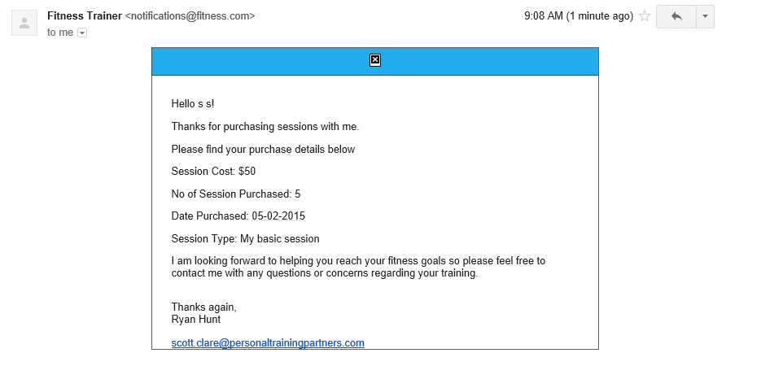
Should say Purchase Cost: $50

All dates should be formatted: 05/02/2015

Need trainers phone number to populate at bottom (above his email)

For some reason this logo is not showing up but it is uploaded in my trainer account

9:16 AM (5 minutes ago)
Let’s have all correspondence through our system from trainer to client say “Personal Training” instead of trying to use the trainer’s name. I don’t think Google likes us using the trainers name and having it come from our site...

7: Mail Type: Client Session Reminder
Mail Subject: Session Reminder
(Trainer’s Logo)
Hello (client’s name),
Just a reminder that we have a workout scheduled for (date and time of session). See you then!
Thank you,
(Trainer Name)
(Trainer Phone)

[SynapseIndia]-: We are working on this via cron job.

8: Mail Type: Client Session Notification
Mail Subject: Session Status
(Trainier’s Logo)

Hello (Client Name),
Your session on (date) has been (completed, cancelled no charge, cancelled charged, comped). As always, it’s a pleasure to help you reach your fitness goals. Feel free to contact me anytime with questions regarding your training.
Thank You,
(trainer name)
(trainer phone)

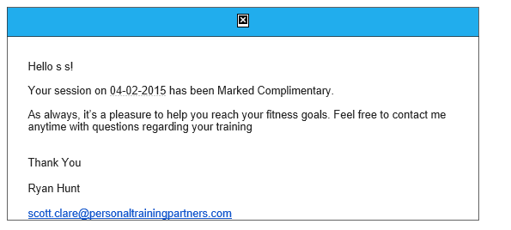
All dates should be formatted: 05/02/2015

For some reason this logo is not showing up but it is uploaded in my trainer account

Need the trainers phone number to be fetched and placed above trainers email

Let’s have all correspondence through our system from trainer to client say “Personal Training” instead of trying to use the trainer’s name. I don’t think Google likes us using the trainers name and having it come from our site...

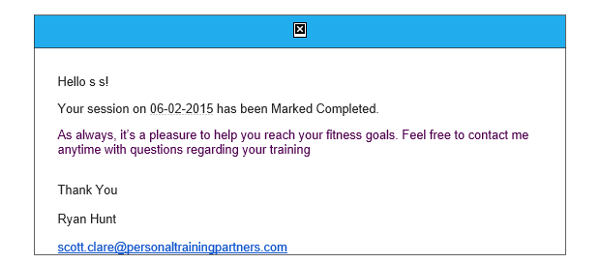
All dates should be formatted: 05/02/2015

For some reason this logo is not showing up but it is uploaded in my trainer account

Need the trainers phone number to be fetched and placed above trainers email

Let’s have all correspondence through our system from trainer to client say “Personal Training” instead of trying to use the trainer’s name. I don’t think Google likes us using the trainers name and having it come from our site..
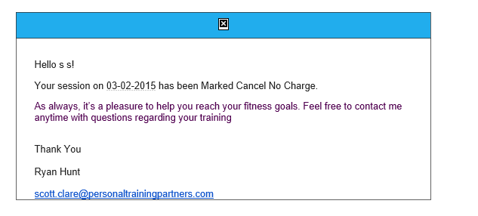
All dates should be formatted: 05/02/2015

For some reason this logo is not showing up but it is uploaded in my trainer account

Need the trainers phone number to be fetched and placed above trainers email

Let’s have all correspondence through our system from trainer to client say “Personal Training” instead of trying to use the trainer’s name. I don’t think Google likes us using the trainers name and having it come from our site..

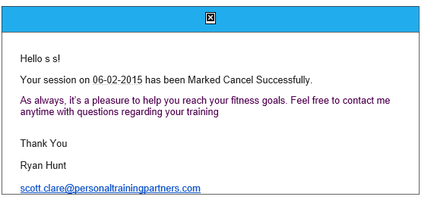
Need it to read: Marked Cancelled Charged

All dates should be formatted: 05/02/2015

For some reason this logo is not showing up but it is uploaded in my trainer account

Need the trainers phone number to be fetched and placed above trainers email

Let’s have all correspondence through our system from trainer to client say “Personal Training” instead of trying to use the trainer’s name. I don’t think Google likes us using the trainers name and having it come from our site…

8: This is an email that was generated from a trainer to his client using the trainer’s communication center to send the email.
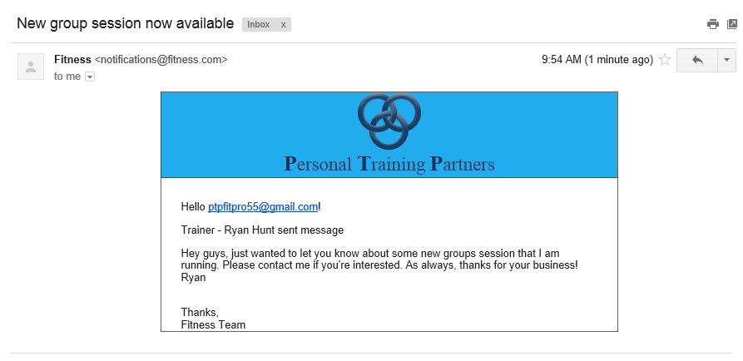

Let’s have all correspondence through our system from trainer to client say “Personal Training” instead of trying to use the trainer’s name. I don’t think Google likes us using the trainers name and having it come from our site…

Should say Hello (trainer’s name) not his email

Need “trainer – ryan hunt sent message to be removed

Please remove “thanks, fitness team” …… and replace with trainer’s name, phone, and email

9: This is an email sent from a client to his trainer in the client communication center
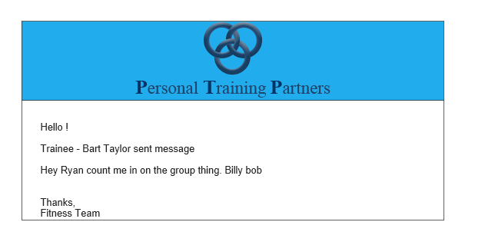

Should read Hello (trainer’s name)

Should say; client – bart taylor sent you a message

Remove: thanks, fitness team

Let’s have all correspondence through our system from trainer to client say “Personal Training” instead of trying to use the trainer’s name. I don’t think Google likes us using the trainers name and having it come from our site…

____________________________________

